

**(DIGITAL ASSIGNMENT - 1) ARRAY AND STRINGS**

**CSE1007(JAVA PROGRAMMING)LAB:L31-L32**



**January 31, 2022**

**ANIRUDH VADERA**

**20BCE2940**

**STRINGS AND ARRAYS IN JAVA:**

**STRINGS:**

In Java, string is basically an object that represents sequence of char values. An array of characters works same as Java string.

**Java String** class provides a lot of methods to perform operations on strings such as compare(), concat(), equals(), split(), length(), replace(), compareTo(), intern(), substring() etc.

The java.lang.String class implementsSerializable*,*Comparable*and*CharSequence interfaces.

Generally, String is a sequence of characters. But in Java, string is an object that represents a sequence of characters. The java.lang.String class is used to create a string object.

**ARRAYS:**

Normally, an array is a collection of similar type of elements which has contiguous memory location.

**Java array** is an object which contains elements of a similar data type. Additionally, the elements of an array are stored in a contiguous memory location. It is a data structure where we store similar elements. We can store only a fixed set of elements in a Java array.

Array in Java is index-based, the first element of the array is stored at the 0th index, 2nd element is stored on 1st index and so on.

Unlike C/C++, we can get the length of the array using the length member. In C/C++, we need to use the sizeof operator.

In Java, array is an object of a dynamically generated class. Java array inherits the Object class, and implements the Serializable as well as Cloneable interfaces. We can store primitive values or objects in an array in Java. Like C/C++, we can also create single dimentional or multidimentional arrays in Java.

Moreover, Java provides the feature of anonymous arrays which is not available in C/C++.

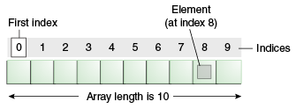

**ACTIVITY – 1:**

**QUESTION:**

***Find BMI of a person by getting weight and height in kg and cm respectively from user. [Formula BMI = kg/m2]***

**CODE:**

import java.util.Scanner;

import java.lang.Math;

class BMI {

    public static void main(String[] args) {

        System.out.println("Enter the weight in kg:");

        Scanner in = new Scanner(System.in);

        double weight = in.nextDouble();

        System.out.println("Enter the height in cm:");

        double height = in.nextDouble();

        height = height / 100.0;

        double BMI = weight / (Math.pow(height, 2));

        System.out.println();

        System.out.println("ANIRUDH VADERA (20BCE2940)");

        System.out.println();

        System.out.println("The BMI is:");

        System.out.println(BMI);

        in.close();

    }

}

**OUTPUT:**

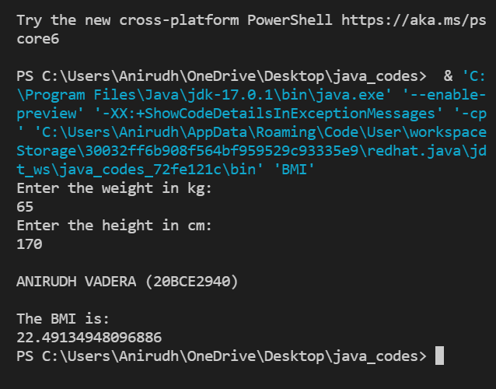

**QUESTION:**

**Write a program to find the simple interest**

**CODE:**

import java.util.Scanner;

class SI {

    public static void main(String[] args) {

        System.out.println("Enter the principal:");

        Scanner in = new Scanner(System.in);

        double p = in.nextDouble();

        System.out.println("Enter the rate of interest per anum:");

        double r = in.nextDouble();

        System.out.println("Enter the no of years:");

        double t = in.nextDouble();

        double SI = (p * r * t) / 100;

        System.out.println();

        System.out.println("ANIRUDH VADERA (20BCE2940)");

        System.out.println();

        System.out.println("The Simple Interest is:");

        System.out.println(SI);

        in.close();

    }

}

**OUTPUT:**

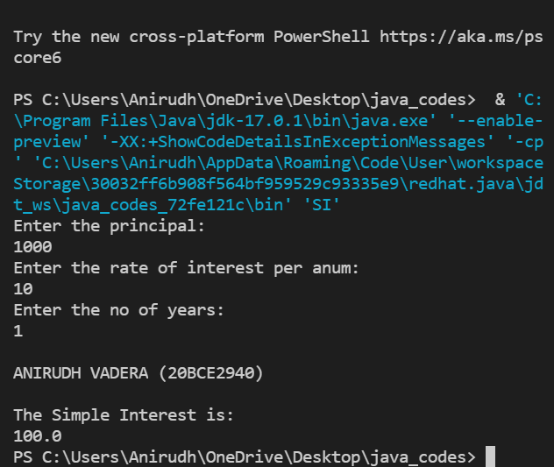

**QUESTION:**

**Write a program to display you name , register number and your cgpa**

**CODE:**

class flex {

    public static void main(String[] args) {

        System.out.println("Anirudh Vadera");

        System.out.println("20BCE2940");

        System.out.println("NCGPA : 9.84 ");

    }

}

**OUTPUT:**

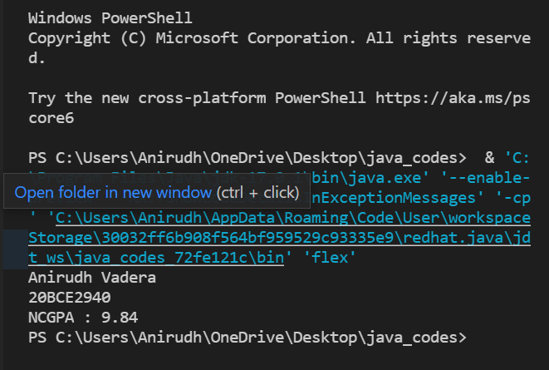

**QUESTION:**

**Write a program to find the area of circle**

**CODE:**

import java.util.Scanner;

class Area {

    public static void main(String[] args) {

        System.out.println("Enter the value of pi:");

        Scanner in = new Scanner(System.in);

        double pi = in.nextDouble();

        System.out.println("Enter the radius:");

        double radius = in.nextDouble();

        double area = pi * radius * radius;

        System.out.println();

        System.out.println("ANIRUDH VADERA (20BCE2940)");

        System.out.println();

        System.out.println("The area is:");

        System.out.println(area);

        in.close();

    }

}

**OUTPUT:**

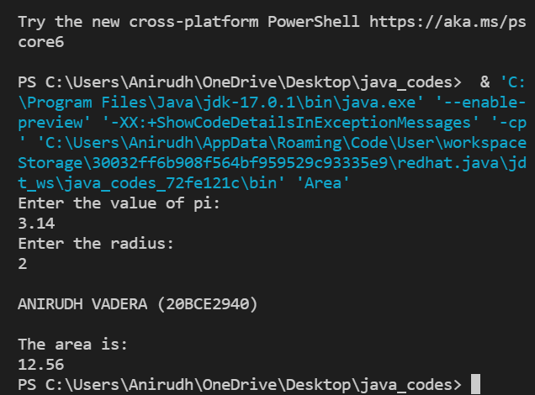

**QUESTION:**

***Check if a given number is odd or even number [using if statement as well as switch case]***

**CODE:**

import java.util.Scanner;

class O_E {

    public static void main(String[] args) {

        System.out.println("Enter the method:");

        System.out.println("1 : if");

        System.out.println("2 : switch");

        Scanner in = new Scanner(System.in);

        int flag = in.nextInt();

        if (flag == 1) {

            System.out.println("Enter the number:");

            int number = in.nextInt();

            System.out.println();

            System.out.println("ANIRUDH VADERA (20BCE2940)");

            System.out.println();

            if (number % 2 == 0) {

                System.out.println("The number is Even");

            } else {

                System.out.println("The number is Odd");

            }

        } else {

            System.out.println("Enter the number:");

            int number = in.nextInt();

            int f = number % 2;

            System.out.println();

            System.out.println("ANIRUDH VADERA (20BCE2940)");

            System.out.println();

            switch (f) {

                case 0:

                    System.out.println("The number is Even");

                    break;

                case 1:

                    System.out.println("The number is Odd");

                    break;

            }

        }

        in.close();

    }

}

**OUTPUT:**

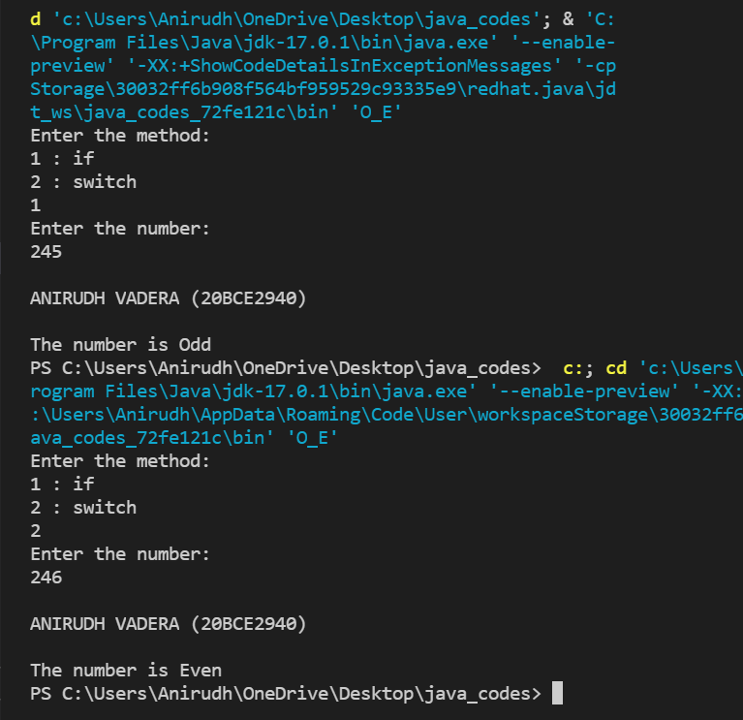

**ACTIVITY – 2:**

**QUESTION:**

**Print the following patterns by finding the table values of stars and spaces.[Any three patterns only]**

1. **\***

**\*\***

**\*\*\***

**CODE:**

class pattenr1 {

    public static void main(String[] args) {

        System.out.println("ANIRUDH VADERA(20BCE2940)");

        for (int i = 0; i < 3; i++) {

            for (int j = 0; j < i + 1; j++) {

                System.out.print("*");

            }

            System.out.println("");

        }

    }

}

**CODE SNAPSHOT:**

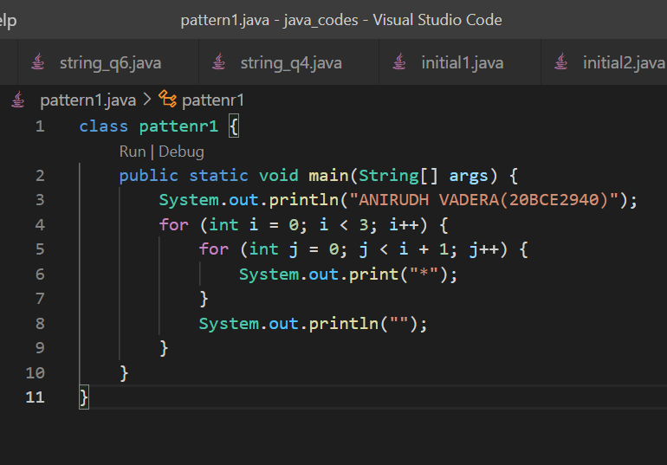

**OUTPUT:**

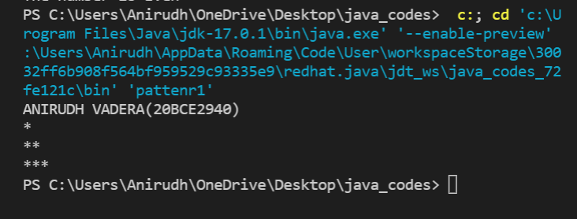

**QUESTION:**

**Print the following patterns by finding the table values of stars and spaces.[Any three patterns only]**

1. **\* \***

**\*\* \*\***

**\*\*\*\*\***

**\*\* \*\***

**\* \***

**CODE:**

class pattenr2 {

    public static void main(String[] args) {

        System.out.println("ANIRUDH VADERA(20BCE2940)");

        for (int m = 0; m < 3; m++) {

            for (int j = 0; j < m + 1; j++) {

                System.out.print("*");

            }

            for (int j = 0; j < 3 - m * 2; j++) {

                System.out.print(" ");

            }

            if (m == 2) {

                for (int j = 0; j < m; j++) {

                    System.out.print("*");

                }

            } else {

                for (int j = 0; j < m + 1; j++) {

                    System.out.print("*");

                }

            }

            System.out.println("");

        }

        for (int m = 1; m >= 0; m--) {

            for (int j = 0; j < m + 1; j++) {

                System.out.print("*");

            }

            for (int j = 0; j < 3 - m * 2; j++) {

                System.out.print(" ");

            }

            if (m == 2) {

                for (int j = 0; j < m; j++) {

                    System.out.print("*");

                }

            } else {

                for (int j = 0; j < m + 1; j++) {

                    System.out.print("*");

                }

            }

            System.out.println("");

        }

    }

}

**CODE SNAPSHOT:**

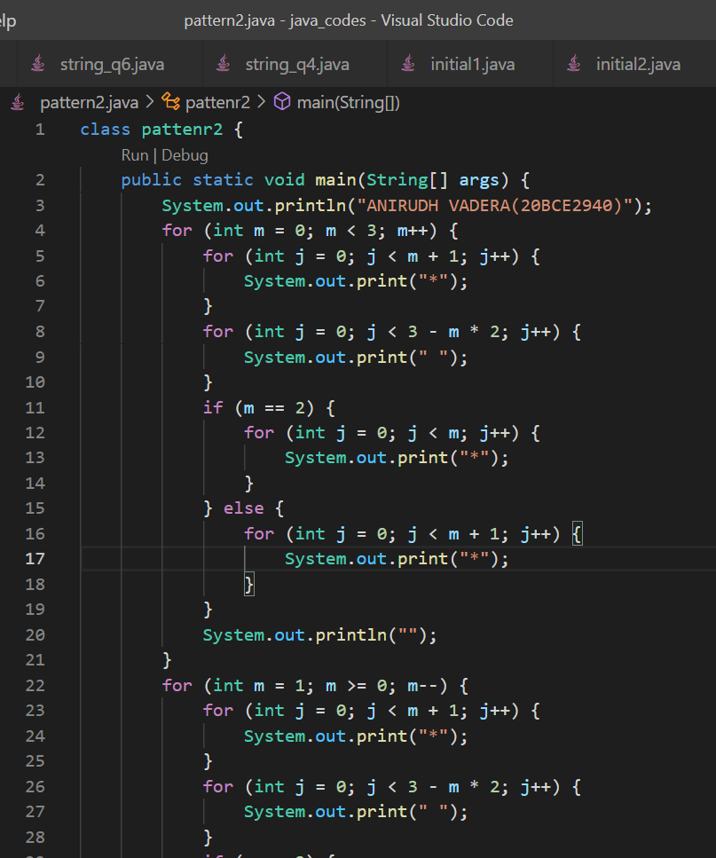

**OUTPUT:**

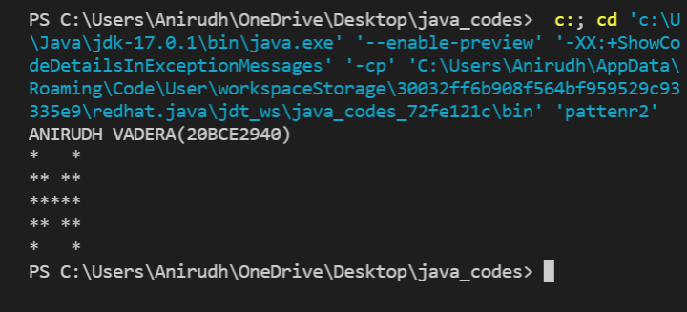

**QUESTION:**

**Print the following patterns by finding the table values of stars and spaces.[Any three patterns only]**

1. **1**

**12**

**123**

**1234**

**123**

**12**

**1**

**CODE:**

class pattenr3 {

    public static void main(String[] args) {

        System.out.println("ANIRUDH VADERA(20BCE2940)");

        for (int i = 0; i < 4; i++) {

            for (int j = 0; j < i + 1; j++) {

                System.out.print(j + 1);

            }

            System.out.println("");

        }

        for (int i = 2; i >= 0; i--) {

            for (int j = 0; j < i + 1; j++) {

                System.out.print(j + 1);

            }

            System.out.println("");

        }

    }

}

**CODE SNAPSHOT:**

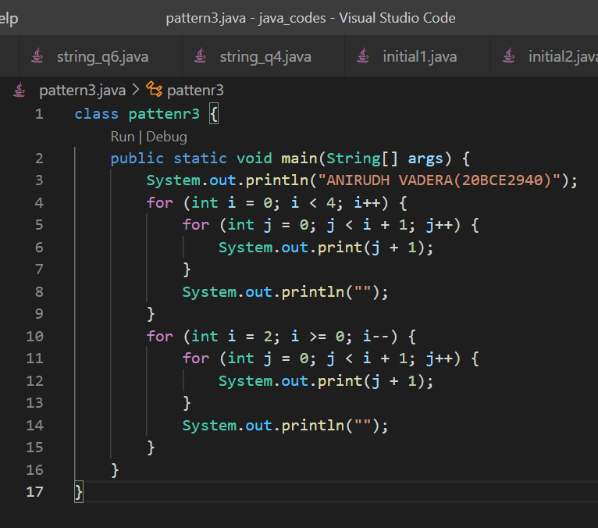

**OUTPUT:**

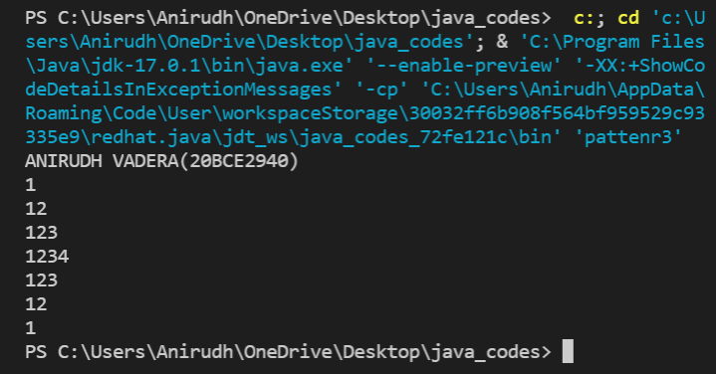

**QUESTION:**

**Find the HCF and LCM of given numbers.**

**CODE:**

import java.util.Scanner;

class hcf_lcm {

    public static void main(String[] args) {

        int temp1, temp2, x, y, temp, hcf, lcm;

        Scanner scanner = new Scanner(System.in);

        System.out.print("Enter First Number: ");

        x = scanner.nextInt();

        System.out.print("Enter Second Number: ");

        y = scanner.nextInt();

        temp1 = x;

        temp2 = y;

        while (temp2 != 0) {

            temp = temp2;

            temp2 = temp1 % temp2;

            temp1 = temp;

        }

        hcf = temp1;

        lcm = (x * y) / hcf;

        System.out.println("ANIRUDH VADERA(20BCE2940)");

        System.out.println("HCF of input numbers: " + hcf);

        System.out.println("LCM of input numbers: " + lcm);

        scanner.close();

    }

}

**CODE SNAPSHOT:**

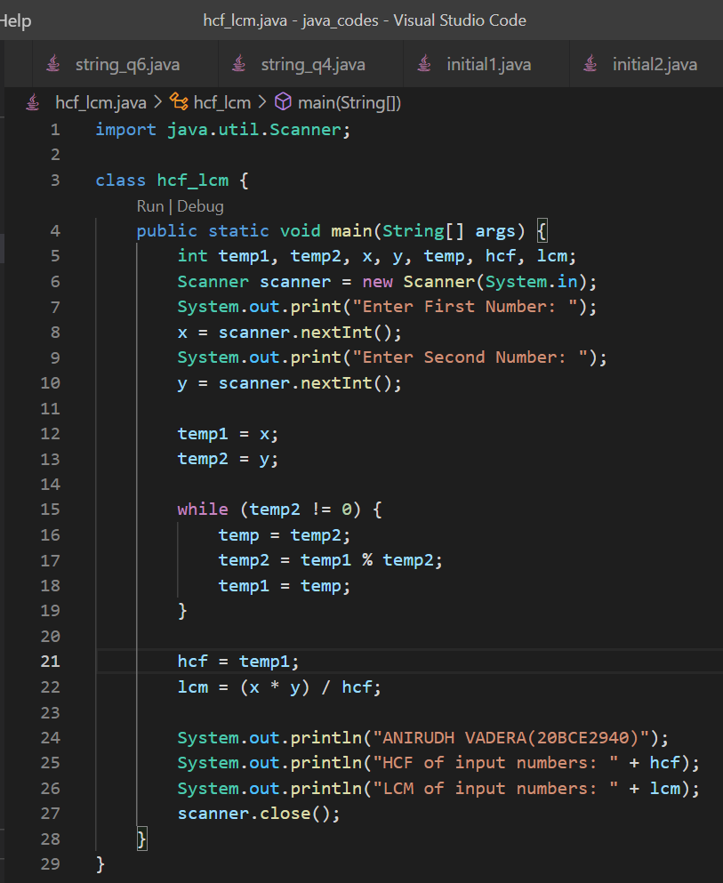

**OUTPUT:**

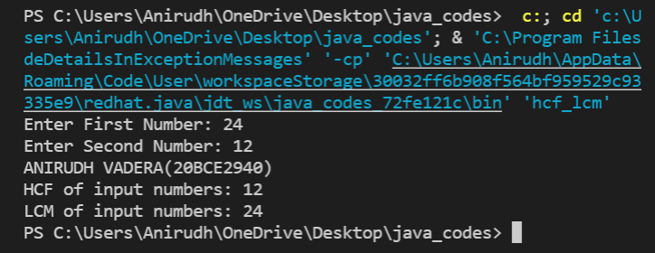

**QUESTION:**

**Ask the user to enter the marks of a student in the below order.**

* **Maths, M**
* **Physics, P**
* **Chemistry, C**
* **English, E**
* **Computer Science, CS**

**And calculate the metrics according to the below table.**

**Metric Formula :**

* **Overall Average (OA)** 
  + **Sum of all the marks / total number of subjects**
* **Engineering Average (EA)** 
  + **Sum of (M * 2), P and C / 4**
* **Computer Science Average (CSA)** 
  + **CS**

**Print the output according to the below table:**

**Case Output**

* **If OA > 75 and EA > CSA** 
  + **Probable Mech, Civil, EEE, ECE candidate**
* **If OA > 75 and CSA > EA** 
  + **Probable CSE, IT, IS candidate**
* **If OA < 75 and CSA > EA** 
  + **Probable BCA candidate**
* **If OA < 75 and CSA > EA** 
  + **Probable BSc candidate**

**CODE:**

import java.util.Scanner;

class q3 {

    public static void main(String[] args) {

        int maths, phy, chem, eng, cse;

        Scanner scanner = new Scanner(System.in);

        System.out.print("Enter the marks for Maths : ");

        maths = scanner.nextInt();

        System.out.print("Enter the marks for Physics : ");

        phy = scanner.nextInt();

        System.out.print("Enter the marks for Chemistry : ");

        chem = scanner.nextInt();

        System.out.print("Enter the marks for English : ");

        eng = scanner.nextInt();

        System.out.print("Enter the marks for Computer Science : ");

        cse = scanner.nextInt();

        float O_average, E_average, CS_average;

        O_average = (maths + phy + chem + eng + cse) / 5;

        E_average = ((maths * 2) + phy + chem) / 4;

        CS_average = cse;

        System.out.println("ANIRUDH VADERA(20BCE2940)");

        if (O_average > 75 & E_average > CS_average) {

            System.out.println("Given Current Marks Student is a Probable Mech, Civil, EEE, ECE candidate");

        }

        if (O_average > 75 & E_average <= CS_average) {

            System.out.println("Given Current Marks Student is a Probable CSE, IT, IS candidate");

        }

        if (O_average < 75 & E_average < CS_average) {

            System.out.println("Given Current Marks Student is a Probable BCA candidate");

        }

        if (O_average < 75 & E_average > CS_average) {

            System.out.println("Given Current Marks Student is a Probable BSc candidate");

        }

        scanner.close();

    }

}

**CODE SNAPSHOT:**

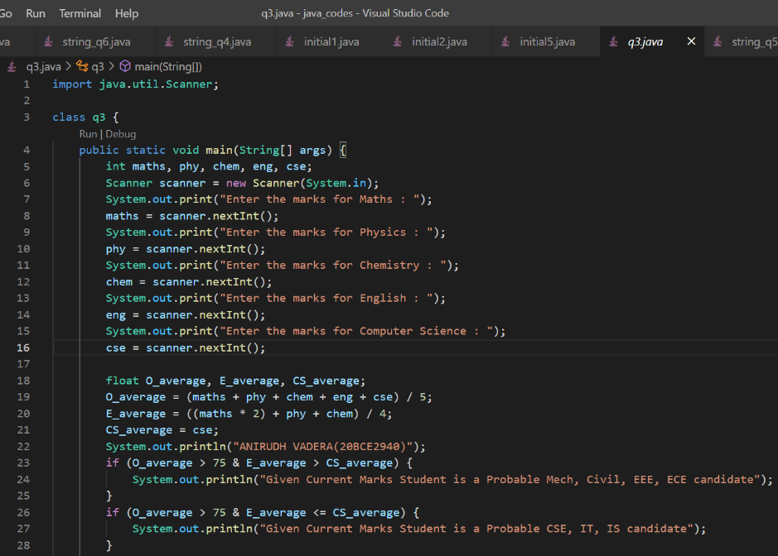

**OUTPUT:**

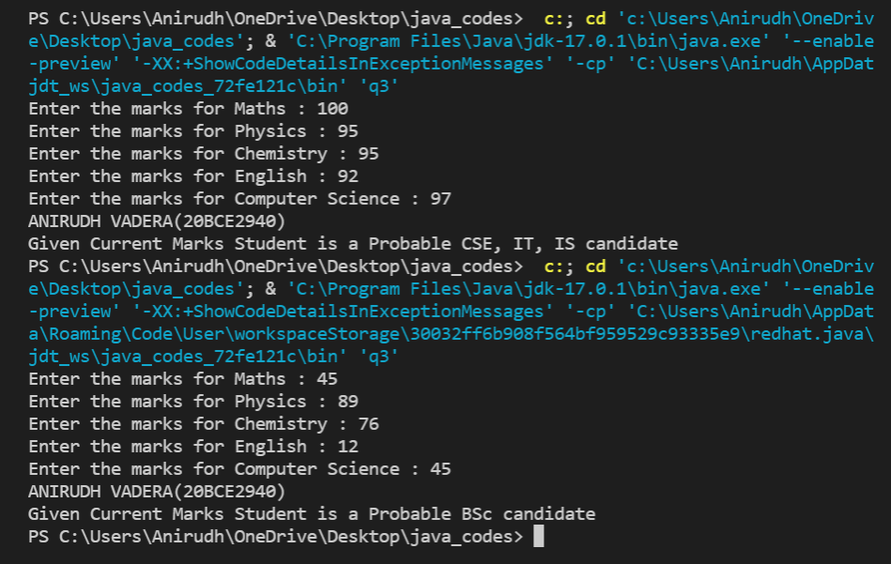

**QUESTION:**

**Write a program to calculate the monthly Electricity bills as per the following tariff.**

**Minimum Rs. 200 for up to 100 units**

**Plus Rs. 0.60 per next 50 units consumed**

**Plus Rs. 1.20 per next 50 units consumed**

**Plus Rs. 2.40 per beyond 200 units consumed**

**CODE:**

import java.util.Scanner;

class q4 {

    public static void main(String[] args) {

        int units;

        Scanner scanner = new Scanner(System.in);

        System.out.print("Enter the units consumed for calculating Electricity Bill : ");

        units = scanner.nextInt();

        System.out.println("ANIRUDH VADERA(20BCE2940)");

        if (units <= 100) {

            System.out.print("Electricity Bill : Rs 200");

        } else {

            units = units - 100;

            float bill = 0;

            if (units <= 50) {

                bill += 200;

                bill += 0.60 * units;

                System.out.print("Electricity Bill : Rs " + bill);

            } else {

                units = units - 50;

                bill = 0;

                if (units <= 50) {

                    bill += 200;

                    bill += 0.6 * 50;

                    bill += 1.2 * units;

                    System.out.print("Electricity Bill : Rs " + bill);

                } else {

                    units = units - 50;

                    bill = 0;

                    if (units <= 50) {

                        bill += 200;

                        bill += 0.6 * 50;

                        bill += 1.2 * 50;

                        bill += 2.4 * units;

                        System.out.print("Electricity Bill : Rs " + bill);

                    }

                }

            }

        }

        scanner.close();

    }

}

**CODE SNAPSHOT:**

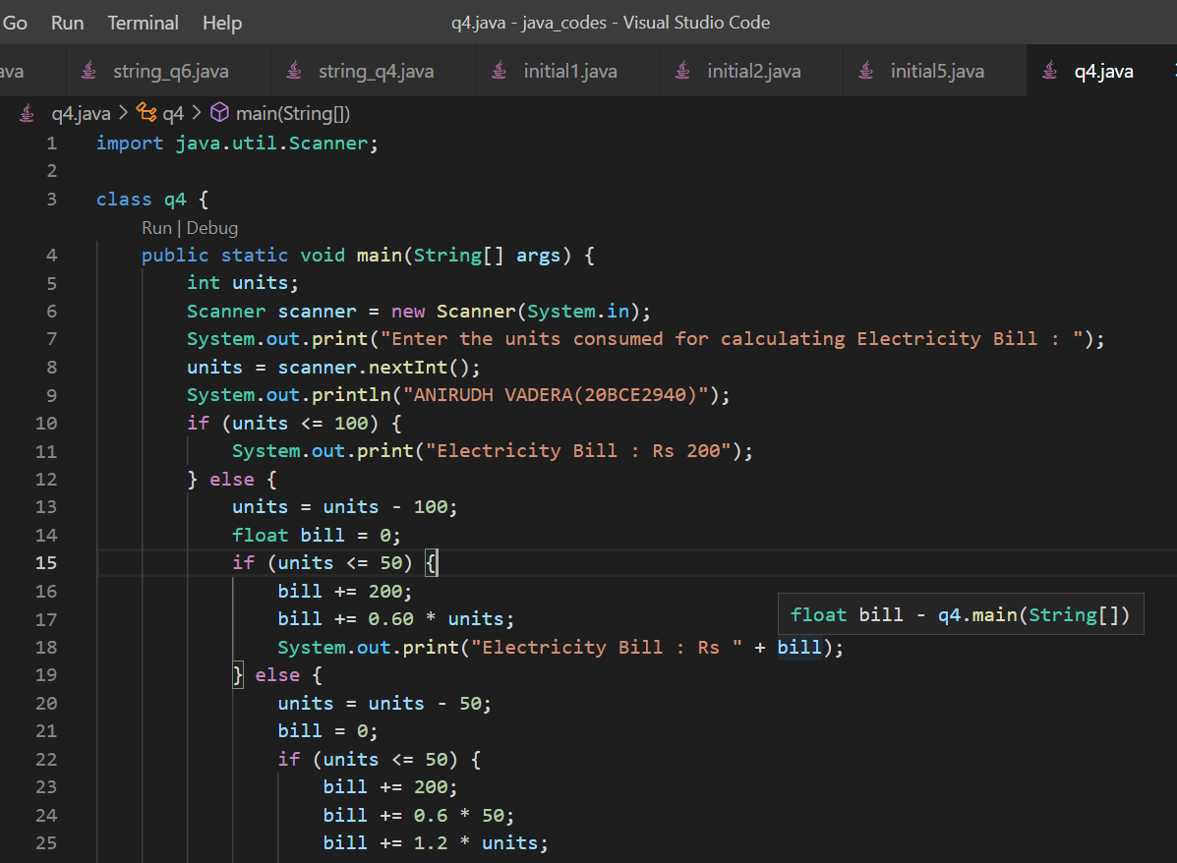

**OUTPUT:**

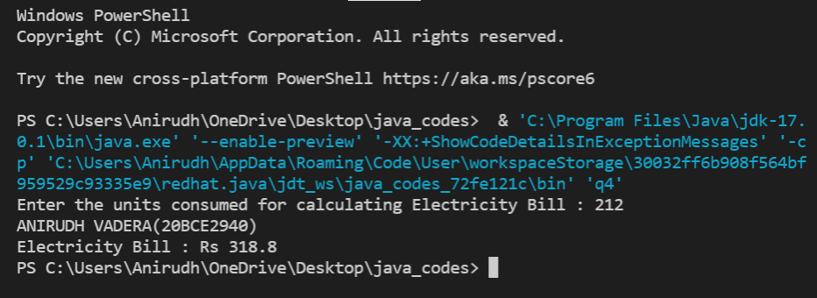

**QUESTION:**

**Develop a Java to that calculates the Addition, Subtraction, Multiplication and Division using menu driven approach. (Do…while loop)**

**CODE:**

import java.util.Scanner;

class q5 {

    static float addition(float a, float b) {

        float result = 0;

        result = a + b;

        return result;

    }

    static float subtraction(float a, float b) {

        float result = 0;

        result = a - b;

        return result;

    }

    static float multiplication(float a, float b) {

        float result = 0;

        result = a * b;

        return result;

    }

    static float division(float a, float b) {

        float result = 0;

        result = a / b;

        return result;

    }

    public static void main(String[] args) {

        float num1, num2, result;

        Scanner scanner = new Scanner(System.in);

        int flag;

        System.out.println("ANIRUDH VADERA(20BCE2940)");

        do {

            System.out.println("Press 1 for : Addition");

            System.out.println("Press 2 for : Subtraction");

            System.out.println("Press 3 for : Multiplication");

            System.out.println("Press 4 for : Division");

            System.out.println("Press 5 for : Exit");

            System.out.print("Enter the number 1 for calculation : ");

            num1 = scanner.nextFloat();

            System.out.print("Enter the number 2 for calculation : ");

            num2 = scanner.nextFloat();

            flag = scanner.nextInt();

            System.out.println("ANIRUDH VADERA(20BCE2940)");

            if (flag == 1) {

                result = addition(num1, num2);

                System.out.println("The result is : " + result);

            }

            if (flag == 2) {

                result = subtraction(num1, num2);

                System.out.println("The result is : " + result);

            }

            if (flag == 3) {

                result = multiplication(num1, num2);

                System.out.println("The result is : " + result);

            }

            if (flag == 4) {

                result = division(num1, num2);

                System.out.println("The result is : " + result);

            }

        } while (flag != 5);

        scanner.close();

    }

}

**CODE SNAPSHOT:**

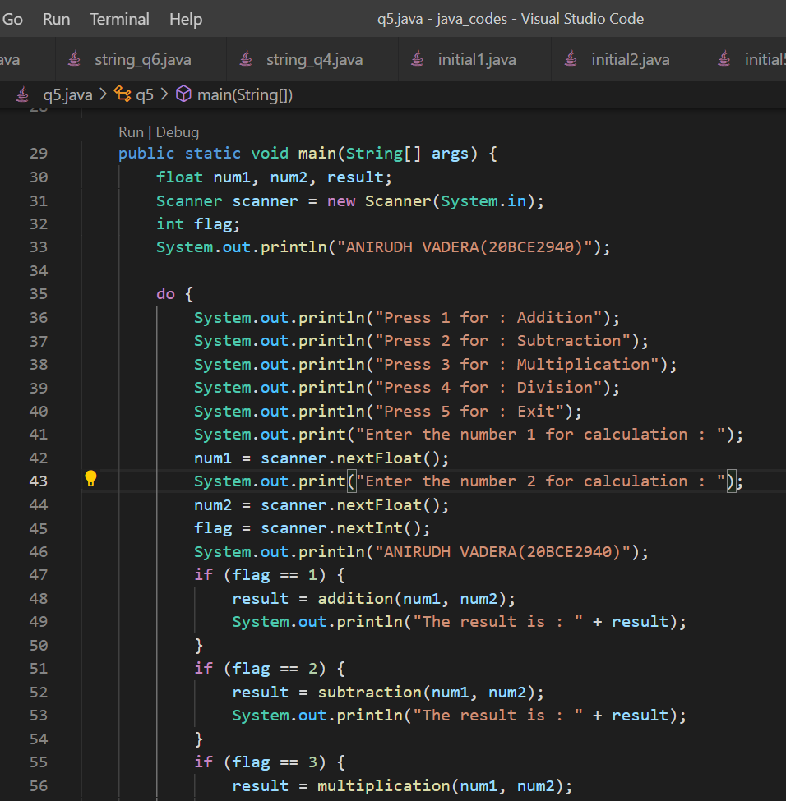

**OUTPUT:**

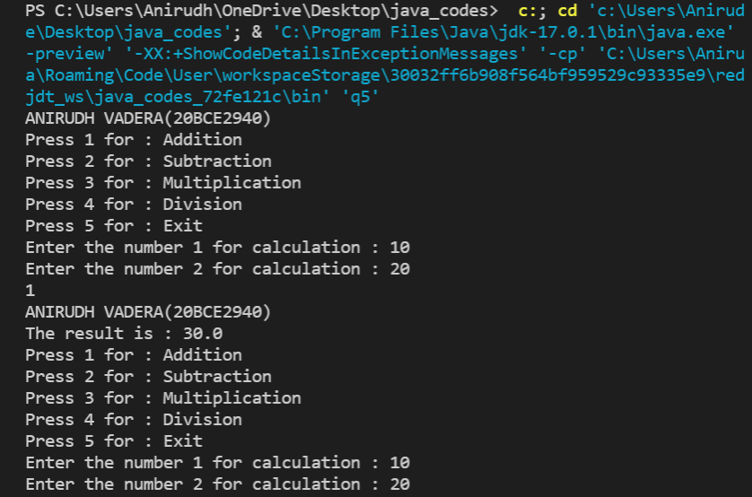 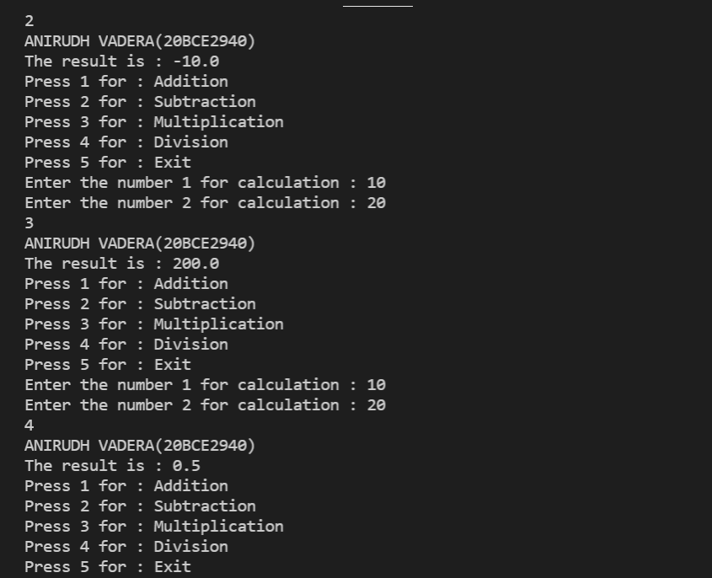 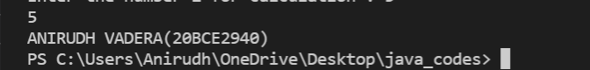

**QUESTION:**

**Write a Java program to get the marks of ‘n students. Write a method to display the elements of array and display them in the reverse order**

**CODE:**

import java.util.Scanner;

class q6 {

    static void display(int[] array, int length) {

        System.out.print("Marks = [ ");

        for (int i = 0; i < length; i++) {

            System.out.print(array[i] + " ");

        }

        System.out.println("]");

    }

    static void display_reverse(int[] array, int length) {

        System.out.print("Marks(Reverse) = [ ");

        for (int i = length - 1; i >= 0; i--) {

            System.out.print(array[i] + " ");

        }

        System.out.print("]");

    }

    public static void main(String[] args) {

        Scanner in = new Scanner(System.in);

        System.out.println("Enter the number of students :");

        int n = in.nextInt();

        System.out.println("Enter the marks for n students :");

        int[] marks = new int[n];

        for (int i = 0; i < n; i++) {

            marks[i] = in.nextInt();

        }

        System.out.println("ANIRUDH VADERA(20BCE2940)");

        display(marks, n);

        display_reverse(marks, n);

        in.close();

    }

}

**CODE SNAPSHOT**

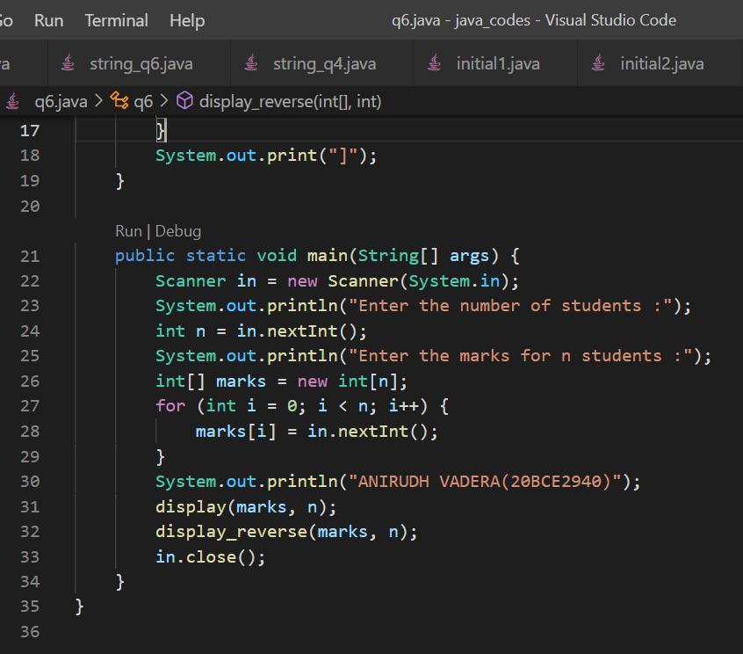

**OUTPUT:**

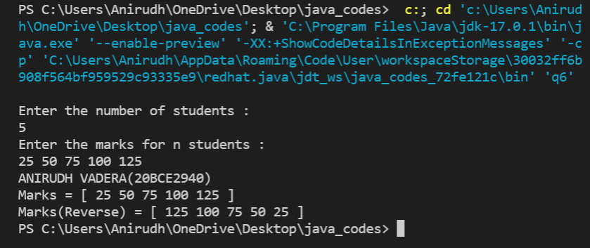

**QUESTION:**

**Sort an array of element using bubble sort**

**CODE:**

import java.util.Scanner;

class q7 {

    static void BubbleSort(int[] array, int length) {

        int temp = 0;

        for (int i = 0; i < length - 1; i++) {

            for (int j = 0; j < (length - i - 1); j++) {

                if (array[j] > array[j + 1]) {

                    // Swapping the required elements

                    temp = array[j];

                    array[j] = array[j + 1];

                    array[j + 1] = temp;

                }

            }

        }

    }

public static void main(String[] args) {

        Scanner in = new Scanner(System.in);

        System.out.println("Enter the number of elements in the array :");

        int n = in.nextInt();

        System.out.println("Enter the elements of the array :");

        int[] array = new int[n];

        for (int i = 0; i < n; i++) {

            array[i] = in.nextInt();

        }

        System.out.println("ANIRUDH VADERA(20BCE2940)");

        System.out.println("The array before sorting is :");

        System.out.print("Array = [ ");

        for (int i = 0; i < n; i++) {

            System.out.print(array[i] + " ");

        }

        System.out.println("]");

        // Applying Bubble Sort

        BubbleSort(array, n);

        System.out.println("The array after sorting is :");

        System.out.print("Array(Sorted) = [ ");

        for (int i = 0; i < n; i++) {

            System.out.print(array[i] + " ");

        }

        System.out.println("]");

        in.close();

    }

}

**CODE SNAPSHOT:**

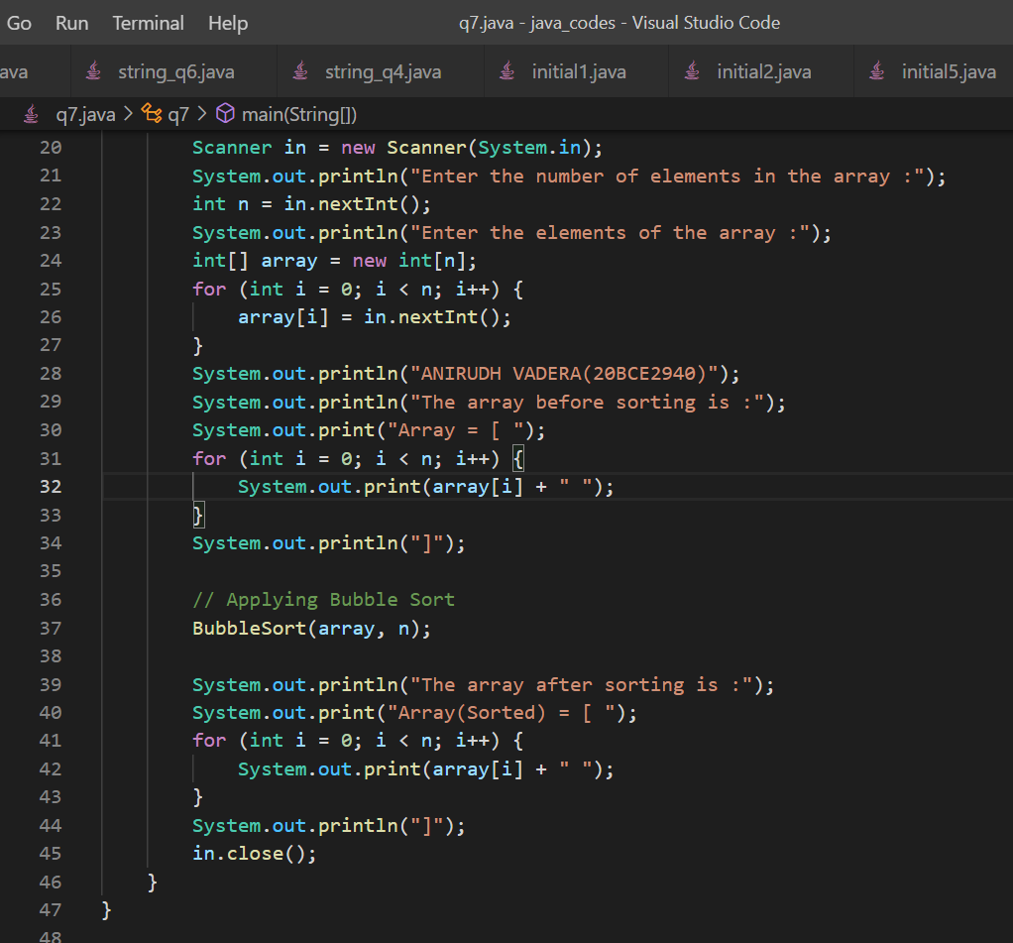

**OUTPUT:**

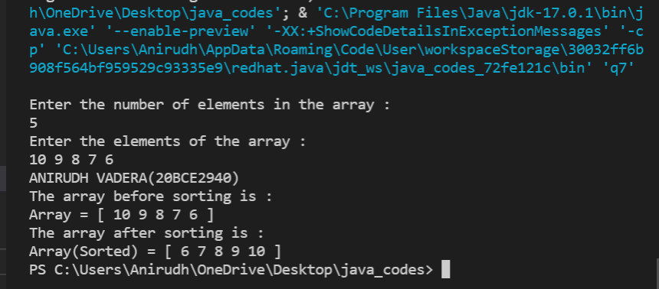

**QUESTION:**

**Remove duplicate elements from a sorted array [only one array should be used]**

**CODE:**

import java.util.Scanner;

class q8 {

    static int RemoveDuplicates(int[] array) {

        int new_length = 0;

        int n = array.length;

        for (int i = 0; i < n - 1; i++) {

            if (array[i] != array[i + 1]) {

                array[new_length++] = array[i];

            }

        }

        array[new_length++] = array[n - 1];

        // Storing the new elements in the original array

        return new_length;

    }

    public static void main(String[] args) {

        Scanner in = new Scanner(System.in);

        System.out.println("Enter the number of elements in the array :");

        int n = in.nextInt();

        System.out.println("Enter the elements of the array :");

        int[] array = new int[n];

        for (int i = 0; i < n; i++) {

            array[i] = in.nextInt();

        }

        System.out.println("ANIRUDH VADERA(20BCE2940)");

        System.out.println("The array before removing duplicates is :");

        System.out.print("Array = [ ");

        for (int i = 0; i < n; i++) {

            System.out.print(array[i] + " ");

        }

        System.out.println("]");

        // Removing the Duplicate elements and recieving the new length of the array

        int new_length = RemoveDuplicates(array);

        System.out.print("Array(Duplicate removed) = [ ");

        for (int i = 0; i < new_length; i++) {

            System.out.print(array[i] + " ");

        }

        System.out.println("]");

        in.close();

    }

}

**CODE SNAPSHOT:**

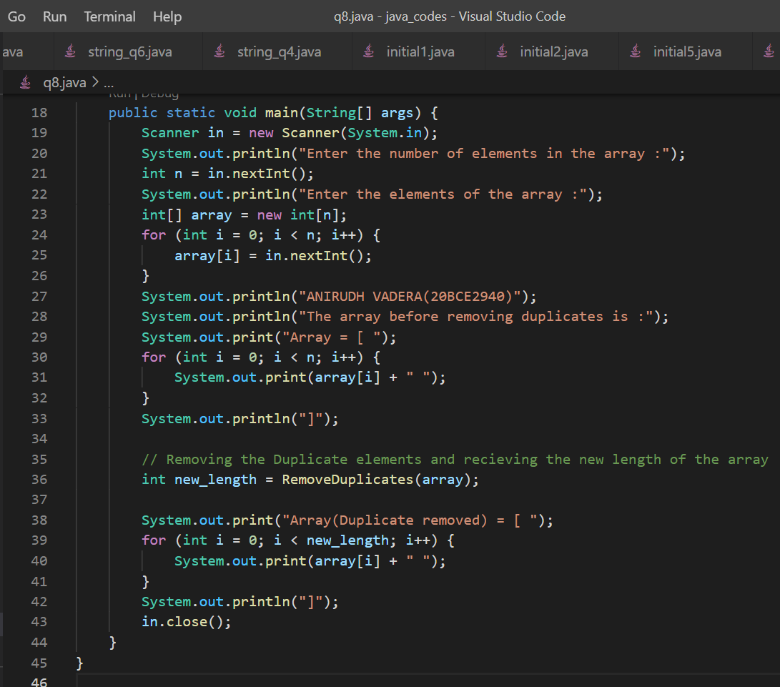

**OUTPUT:**

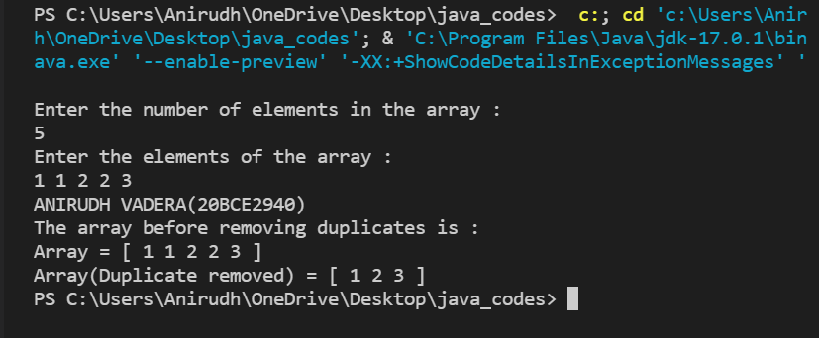

**QUESTION:**

**Check if a given input matrix from a user is an identity matrix**

**CODE:**

import java.util.Scanner;

class q9 {

    static void Identity(int matrix[][]) {

        int flag = 1;

        for (int i = 0; i < matrix.length; i++) {

            for (int j = 0; j < matrix[i].length; j++) {

                if (i == j) {

                    if (matrix[i][j] != 1) {

                        flag = 0;

                        break;

                    }

                } else {

                    if (matrix[i][j] != 0) {

                        flag = 0;

                        break;

                    }

                }

            }

        }

        if (flag == 0) {

            System.out.println("The entered matrix is not a Identity matrix:");

        } else {

            System.out.println("The entered matrix is a Identity matrix:");

        }

    }

    public static void main(String[] args) {

        Scanner in = new Scanner(System.in);

        System.out.println("Enter the no of rows :");

        int r = in.nextInt();

        System.out.println("Enter the no of columns :");

        int c = in.nextInt();

        int matrix[][] = new int[r][c];

        System.out.println("Enter the elements of matrix 1 :");

        for (int i = 0; i < matrix.length; i++) {

            for (int j = 0; j < matrix[i].length; j++) {

                matrix[i][j] = in.nextInt();

            }

        }

        System.out.println("ANIRUDH VADERA(20BCE2940)");

        System.out.println("The matrix entered is :");

        for (int i = 0; i < matrix.length; i++) {

            for (int j = 0; j < matrix[i].length; j++) {

                System.out.print(matrix[i][j] + " ");

            }

            System.out.println();

        }

        // Checking for identity matrix

        Identity(matrix);

        in.close();

    }

}

**CODE SNAPSHOT:**

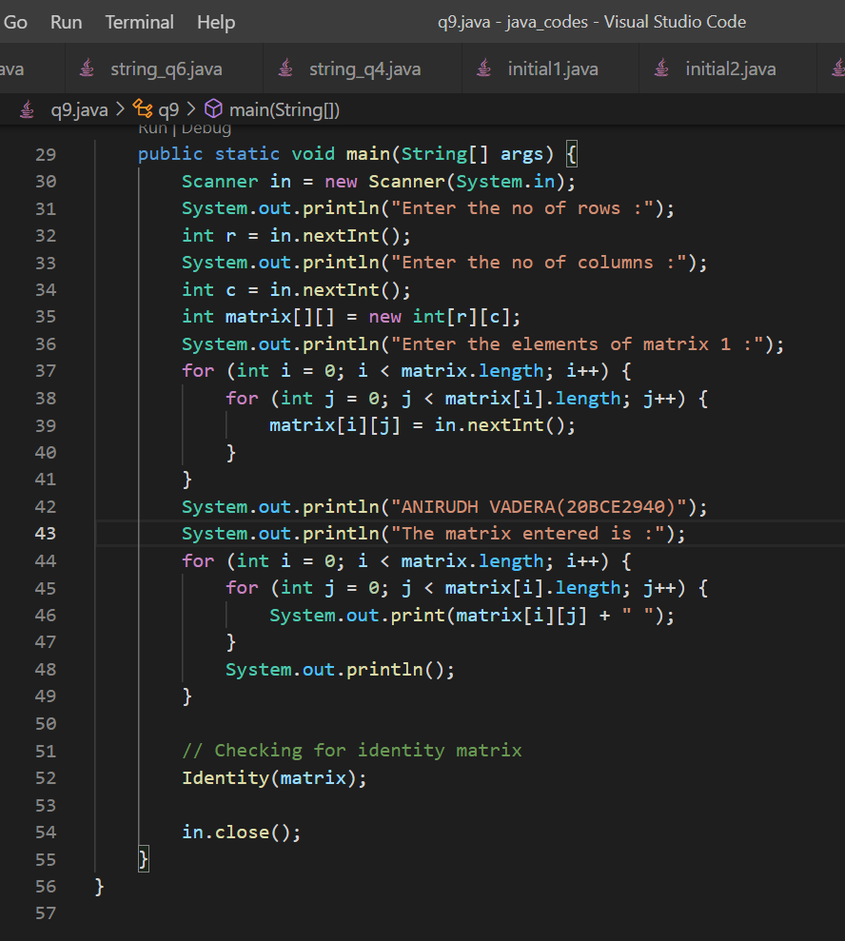

**OUTPUT:**

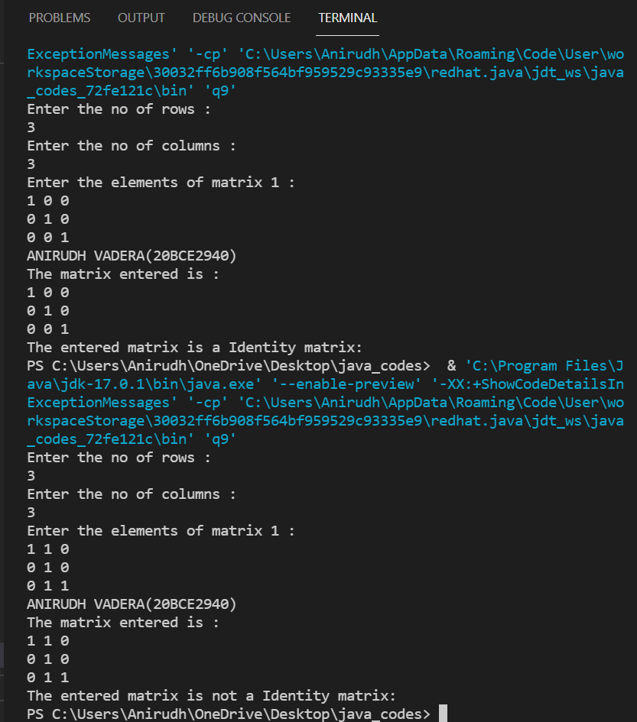

**QUESTION:**

**Display the addition result of two matrices**

**CODE:**

import java.util.Scanner;

class matrixaddition {

    public static void main(String[] args) {

        Scanner in = new Scanner(System.in);

        System.out.println("Enter the no of rows :");

        int r = in.nextInt();

        System.out.println("Enter the no of columns :");

        int c = in.nextInt();

        int matrix1[][] = new int[r][c];

        int matrix2[][] = new int[r][c];

        System.out.println("Enter the elements of matrix 1 :");

        for (int i = 0; i < matrix1.length; i++) {

            for (int j = 0; j < matrix1[i].length; j++) {

                matrix1[i][j] = in.nextInt();

            }

        }

        System.out.println("Enter the elements of matrix 2 :");

        for (int i = 0; i < matrix2.length; i++) {

            for (int j = 0; j < matrix2[i].length; j++) {

                matrix2[i][j] = in.nextInt();

            }

        }

        int result_matrix[][] = new int[r][c];

        for (int i = 0; i < matrix2.length; i++) {

            for (int j = 0; j < matrix2[i].length; j++) {

                result_matrix[i][j] = matrix1[i][j] + matrix2[i][j];

            }

        }

        System.out.println("ANIRUDH VADERA(20BCE2940)");

        System.out.println("The result matrix is :");

        for (int i = 0; i < result_matrix.length; i++) {

            for (int j = 0; j < result_matrix[i].length; j++) {

                System.out.print(result_matrix[i][j] + " ");

            }

            System.out.println();

        }

        in.close();

    }

}

**CODE SNAPSHOT:**

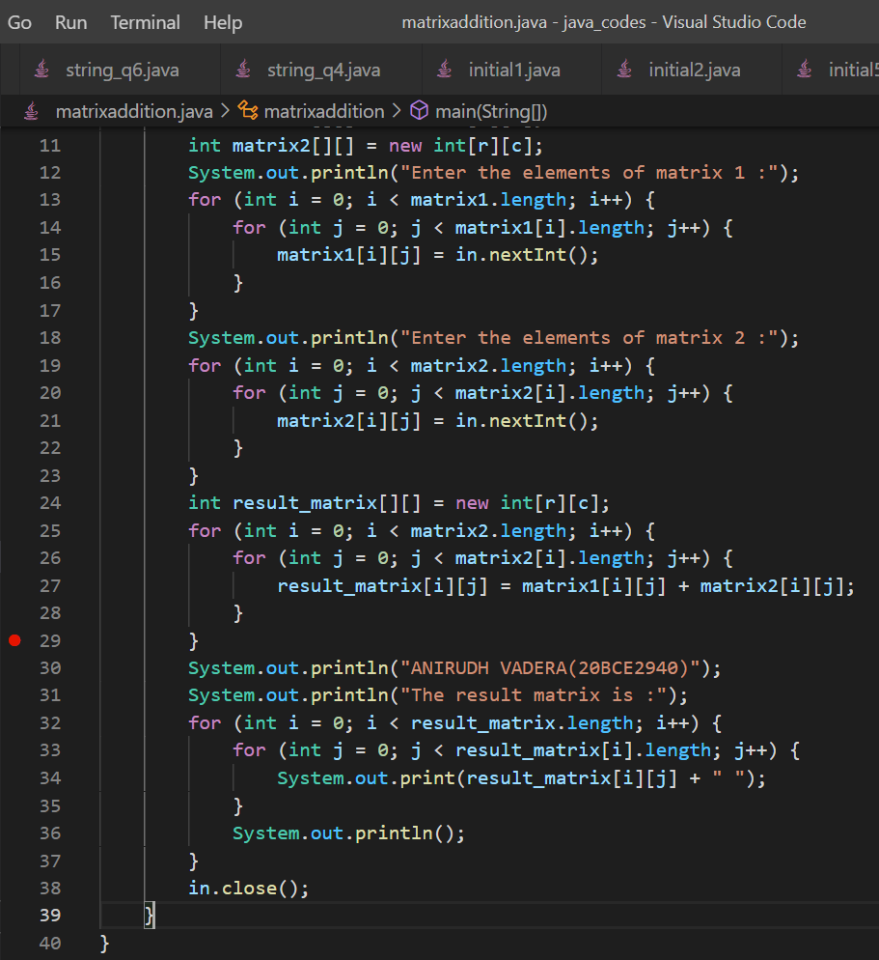

**OUTPUT:**

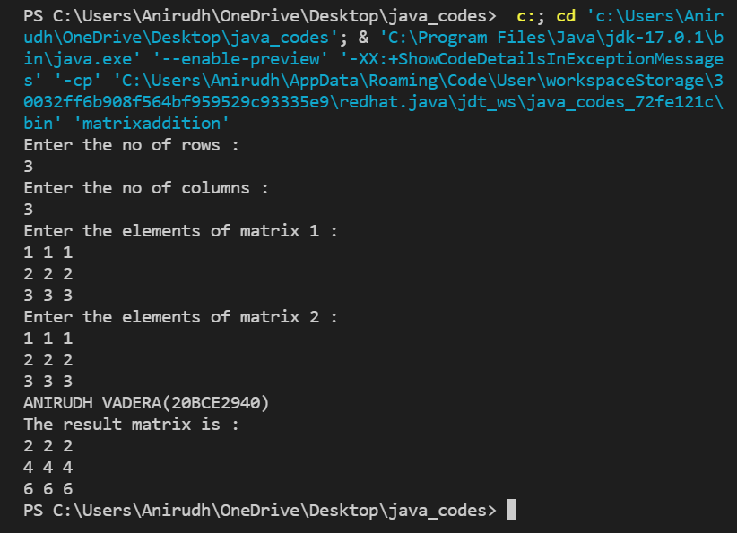

**ACTIVITY – 3:**

**QUESTION:**

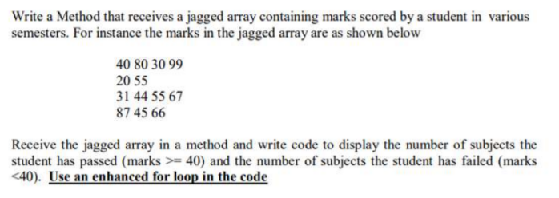

**CODE:**

import java.util.Scanner;

class jagged_array {

    static void passed(int array[][]) {

        int pass_count = 0;

        int fail_count = 0;

        // Enhanced for loop

        for (int[] sub_array : array) {

            for (int data : sub_array) {

                if (data >= 40) {

                    pass_count++;

                } else {

                    fail_count++;

                }

            }

        }

        System.out.println("ANIRUDH VADERA (20BCE2940)");

        System.out.println("Number of subjects students has passed : " + pass_count);

        System.out.println("Number of subjects students has failed : " + fail_count);

    }

    public static void main(String[] args) {

        Scanner in = new Scanner(System.in);

        System.out.println("Enter the number of arrays in the 2D array :");

        int n = in.nextInt();

        int jagged_array[][] = new int[n][];

        System.out.println("Enter the size of each array :");

        for (int i = 0; i < n; i++) {

            int x = in.nextInt();

            jagged_array[i] = new int[x];

        }

        System.out.println("Enter the elements of each array in the 2D array :");

        for (int i = 0; i < jagged_array.length; i++) {

            System.out.println("Array :" + (i + 1));

            for (int j = 0; j < jagged_array[i].length; j++) {

                jagged_array[i][j] = in.nextInt();

            }

        }

        in.close();

        System.out.println("The 2D array is :");

        for (int i = 0; i < jagged_array.length; i++) {

            System.out.print("[");

            for (int j = 0; j < jagged_array[i].length; j++) {

                System.out.print(" " + jagged_array[i][j]);

            }

            System.out.print(" ]");

            System.out.println();

        }

        passed(jagged_array);

    }

}

**CODE SNAPSHOT:**

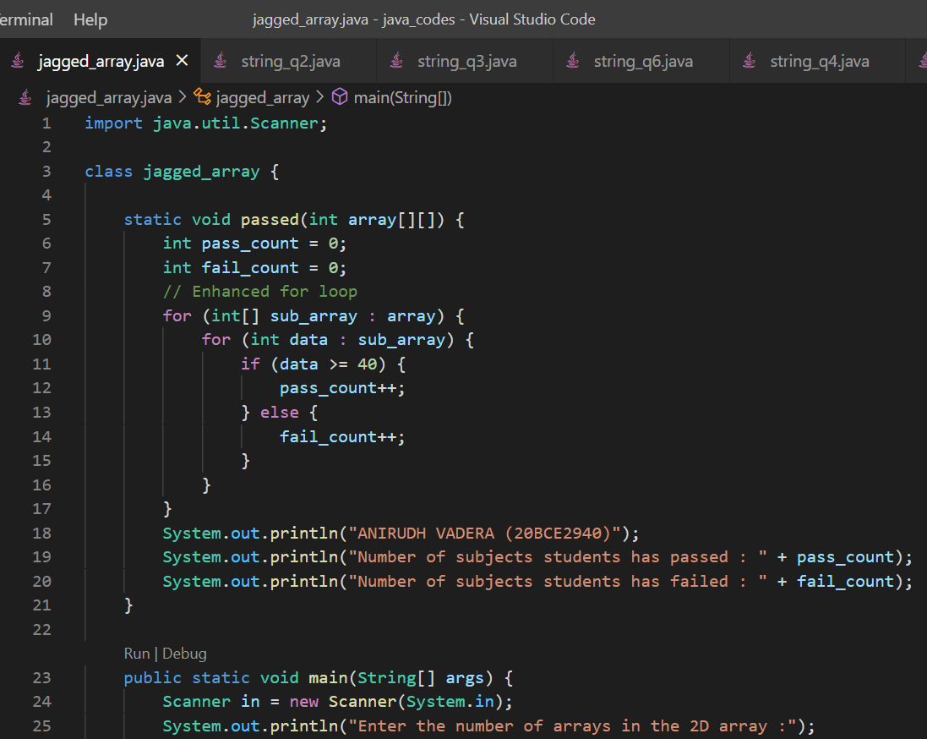

**OUTPUT:**

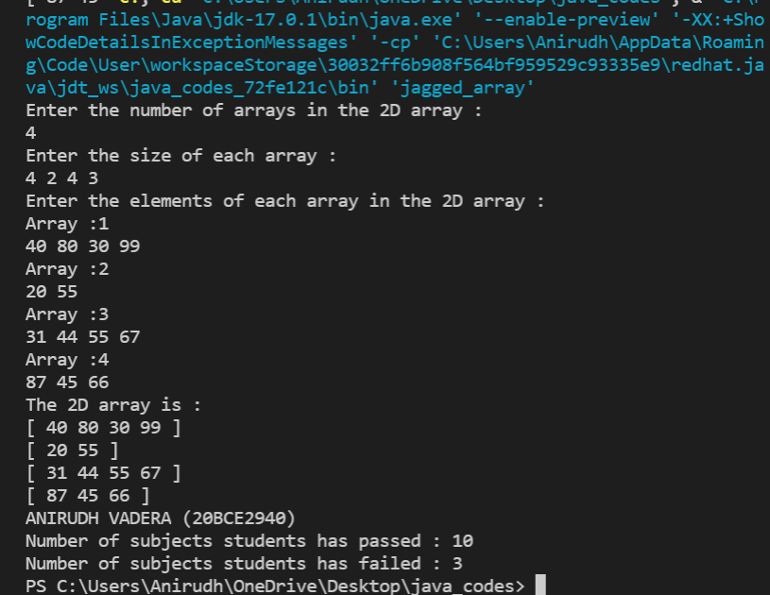

**QUESTION:**

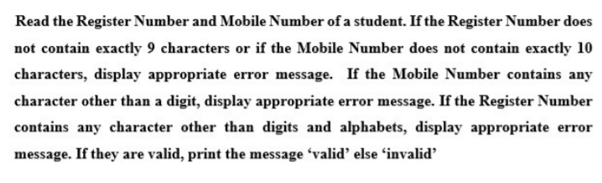

**CODE:**

import java.util.Scanner;

class string_q2 {

    public static void main(String[] args) {

        Scanner in = new Scanner(System.in);

        System.out.println("Enter the Register Number of the Student :");

        String reg_no = new String();

        reg_no = in.nextLine();

        System.out.println("Enter the Mobile Number of the Student :");

        String ph_no = new String();

        ph_no = in.nextLine();

        if ((reg_no.length() != 9)) {

            System.out.println("Error : Entered reg_no doesnt contain 9 digits : Enter again");

            reg_no = in.nextLine();

        } else if ((ph_no.length() != 10)) {

            System.out.println("Error : Entered ph_no doesnt contain 10 digits : Enter again");

            ph_no = in.nextLine();

        }

        System.out.println("ANIRUDH VADERA (20BCE2940)");

        if (reg_no.matches("[a-zA-Z0-9]+") == false) {

            System.out.println("Invalid : The reg_no contain characters other than numbers and alphabets");

        } else if (ph_no.matches("[0-9]+") == false) {

            System.out.println("Invalid : The ph_no contain characters other than numbers");

        } else {

            System.out.println("Valid");

        }

        in.close();

    }

}

**CODE SNAPSHOT:**

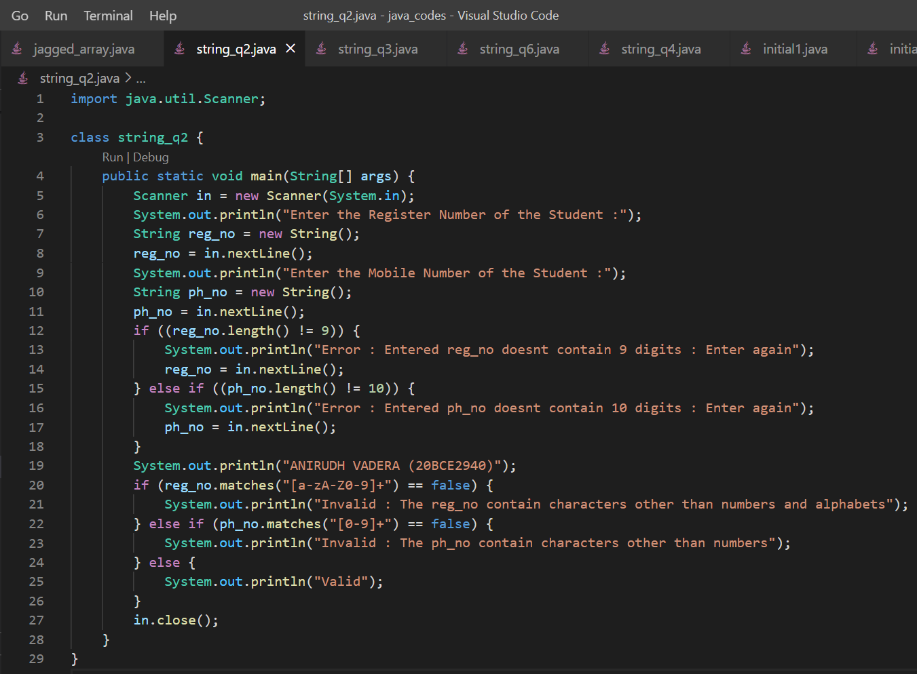

**OUTPUT:**

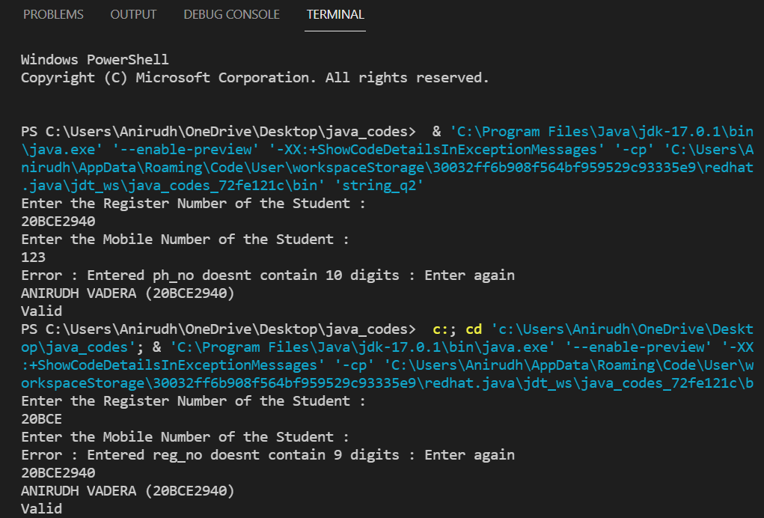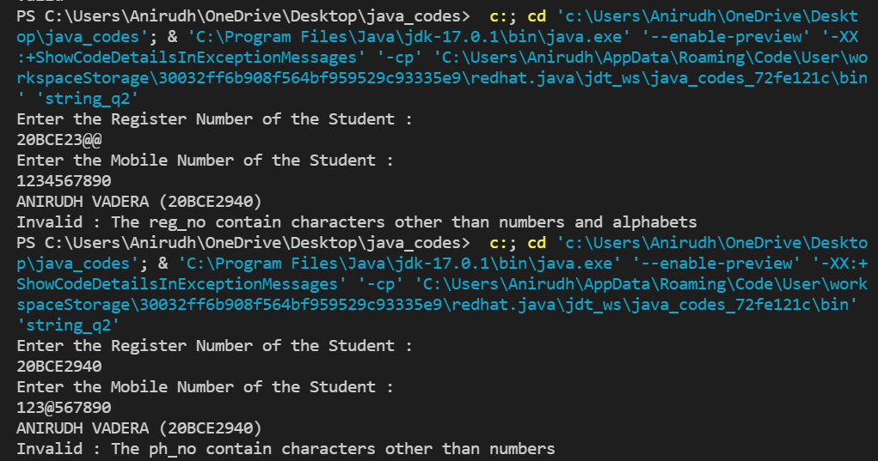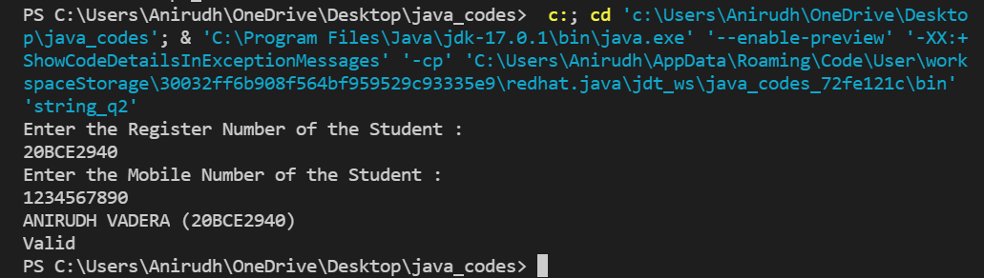

**QUESTION:**

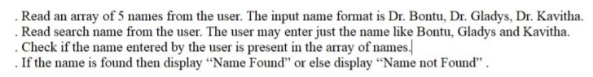

**CODE:**

import java.util.Scanner;

class string_q3 {

    public static void main(String[] args) {

        Scanner in = new Scanner(System.in);

        System.out.println("Enter the number of names to be stored :");

        int n = in.nextInt();

        String[] array = new String[n];

        in.nextLine();

        System.out.println("Enter the names to be stored :");

        for (int i = 0; i < n; i++) {

            String Name = in.nextLine();

            array[i] = Name;

        }

        System.out.println("The Name array is :");

        System.out.print("[ ");

        for (String data : array) {

            System.out.print(data + "  ");

        }

        System.out.print("]");

        System.out.println();

        System.out.println("Enter the name to be searched :");

        String name = in.nextLine();

        System.out.println("ANIRUDH VADERA (20BCE2940)");

        int flag = 0;

        int pos = 0;

        int x = 0;

        for (String data : array) {

            x++;

            if (data.matches("Dr. " + name)) {

                System.out.println("JHo");

                flag = 1;

                pos = x;

                break;

            } else {

                flag = 0;

            }

        }

        if (flag == 0) {

            System.out.println("Name Not Found");

        } else {

            System.out.println("Name Found at position : " + pos);

        }

        in.close();

    }

}

**CODE SNAPSHOT:**

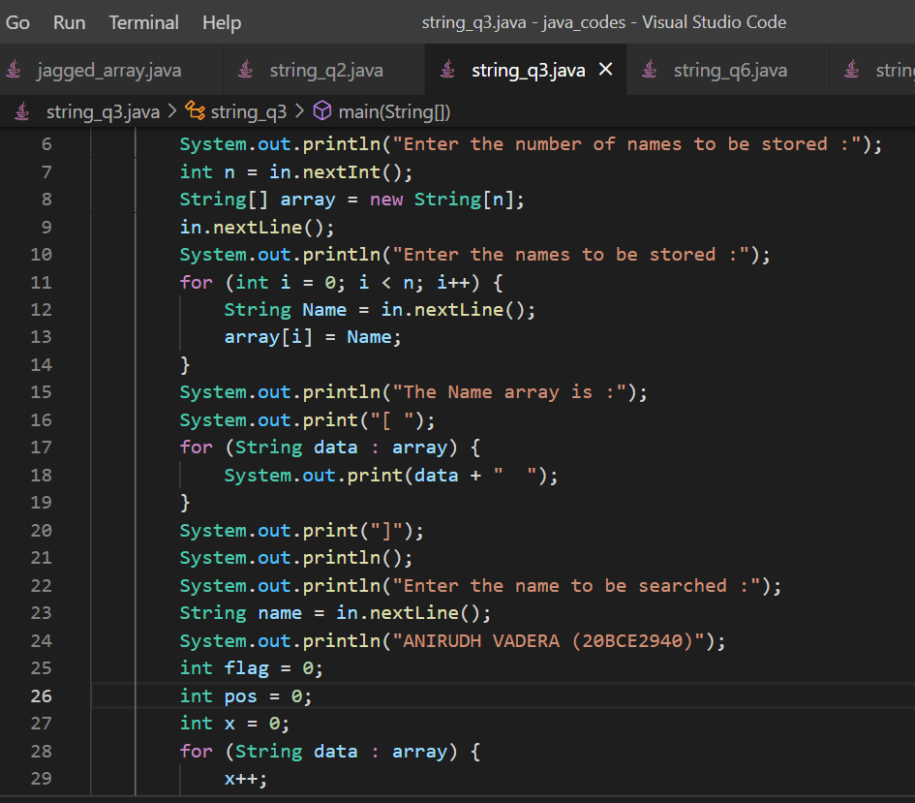

**OUTPUT:**

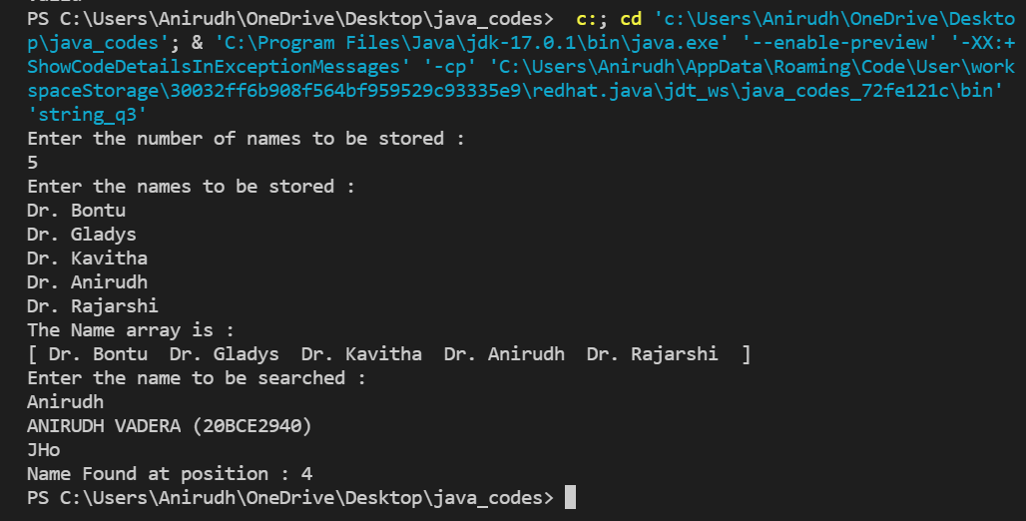

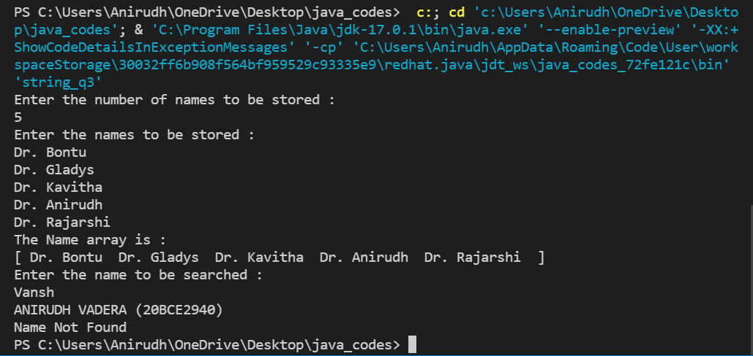

**QUESTION:**

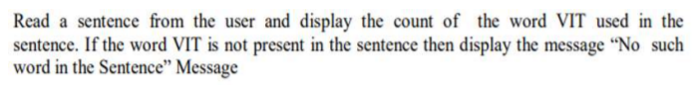

**CODE:**

import java.util.Scanner;

class string_q4 {

    public static void main(String[] args) {

        Scanner in = new Scanner(System.in);

        String str = new String();

        System.out.println("Enter the sentence :");

        str = in.nextLine();

        String[] split_array = str.split(" ");

        int count = 0;

        for (String data : split_array) {

            if (data.matches("VIT")) {

                count++;

            }

        }

        System.out.println("ANIRUDH VADERA (20BCE2940)");

        if (count == 0) {

            System.out.println("No Such word in the Sentence : ");

        }

        System.out.println("The number of times VIT is in the string is : " + count);

        in.close();

    }

}

**CODE SNAPSHOT:**

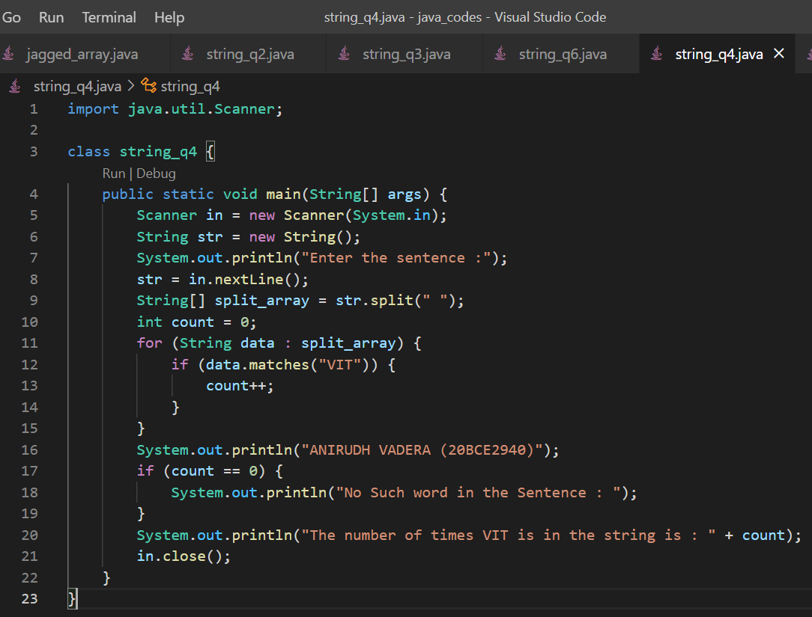

**OUTPUT:**

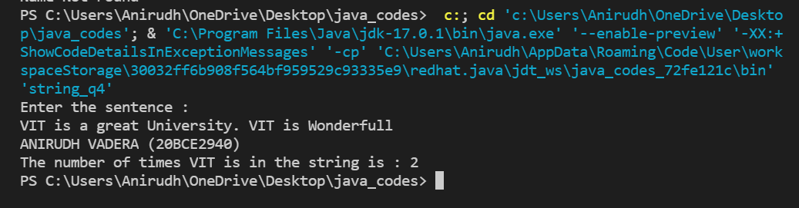

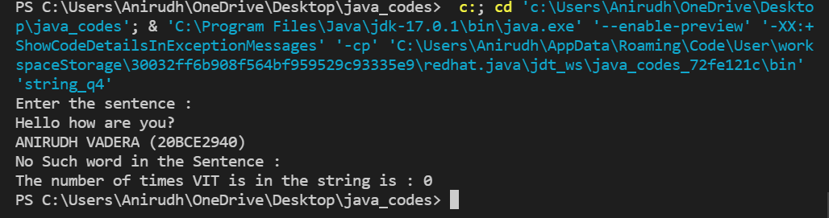

**QUESTION:**

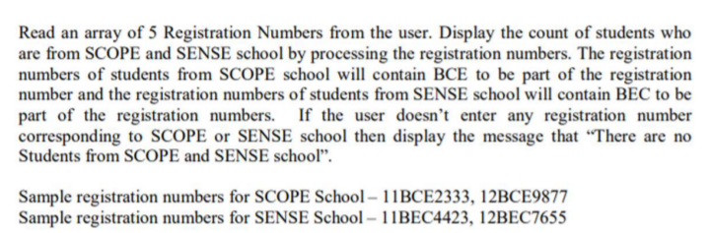

**CODE:**

import java.util.Scanner;

class string_q5 {

    public static void main(String[] args) {

        Scanner in = new Scanner(System.in);

        System.out.println("Enter the number of register numbers to be used :");

        int n = in.nextInt();

        String[] array_reg_no = new String[n];

        in.nextLine();

        System.out.println("Enter the register numbers : ");

        for (int i = 0; i < array_reg_no.length; i++) {

            array_reg_no[i] = in.nextLine();

        }

        System.out.println("The register numbers are : ");

        System.out.print("[ ");

        for (String data : array_reg_no) {

            System.out.print(data + " ");

        }

        System.out.println("]");

        int flag = 0;

        System.out.println("ANIRUDH VADERA (20BCE2940)");

        for (String data : array_reg_no) {

            if (data.contains("BCE")) {

                flag = 1;

                System.out.println(data + ": This Register Number is for SCOPE School");

            } else if (data.contains("BEC")) {

                flag = 2;

                System.out.println(data + ": This Register Number is for SENSE School");

            } else {

                System.out.println(data + ": This Register Number is not from SCOPE either SENSE School");

            }

        }

        if (flag == 0) {

            System.out.println("There are no students from SCOPE and SENSE School");

        }

        in.close();

    }

}

**CODE SNAPSHOT:**

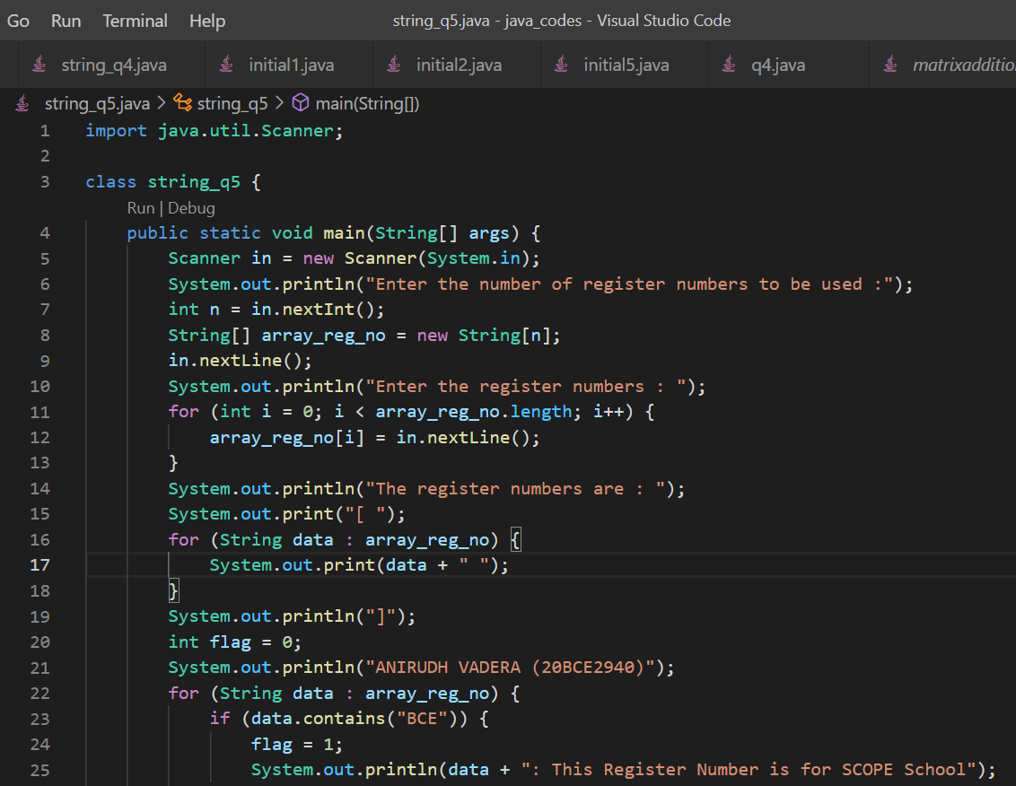

**OUTPUT:**

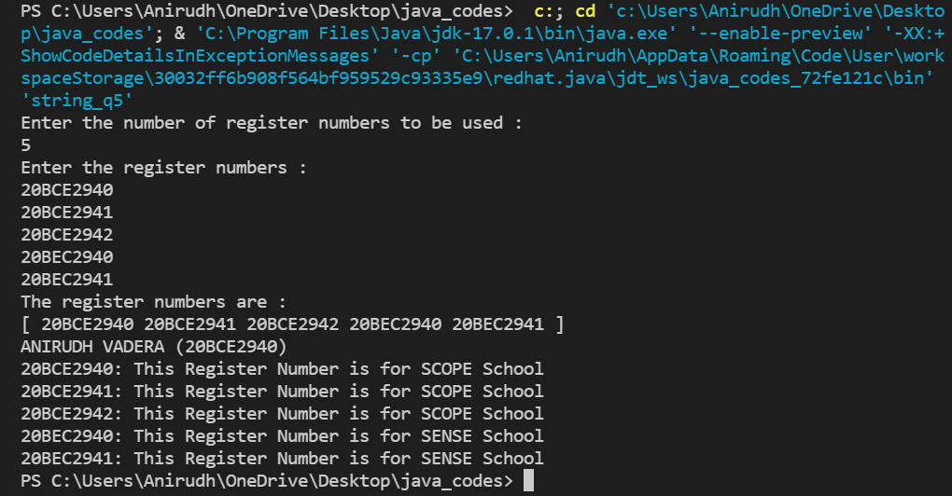

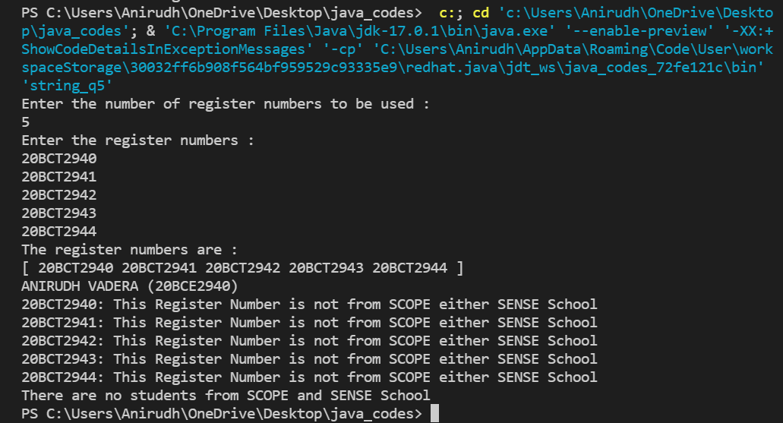

**QUESTION:**

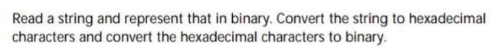

**CODE:**

import java.util.Scanner;

import java.math.BigInteger;

class string_q6 {

    static int StrToBinary(String s) {

        int n = s.length();

        int length = 0;

        for (int i = 0; i < n; i++) {

            int val = Integer.valueOf(s.charAt(i));

            // Convert ASCII value to binary

            String bin = "";

            while (val > 0) {

                if (val % 2 == 1) {

                    bin += '1';

                } else

                    bin += '0';

                val /= 2;

            }

            length = bin.length();

            bin = reverse(bin);

            System.out.print(bin + " ");

        }

        return length;

    }

    static String reverse(String input) {

        char[] a = input.toCharArray();

        int r = 0;

        r = a.length - 1;

        for (int l = 0; l < r; l++, r--) {

            char temp = a[l];

            a[l] = a[r];

            a[r] = temp;

        }

        return String.valueOf(a);

    }

    static String StrtoHex(String str) {

        String hex = new String("");

        for (int i = 0; i < str.length(); i++) {

            char ch = str.charAt(i);

            int in = (int) ch;

            String part = Integer.toHexString(in);

            hex += part;

        }

        return hex;

    }

    static String HexToBinary(String s) {

        return new BigInteger(s, 16).toString(2);

    }

    public static void main(String[] args) {

        Scanner in = new Scanner(System.in);

        String str = new String();

        System.out.println("Enter the string to be converted : ");

        str = in.nextLine();

        System.out.println("ANIRUDH VADERA (20BCE2940)");

        // Method to convert a string into binary:

        System.out.println("The Binary Equivalent of the string is : ");

        int one_length = StrToBinary(str);

        // Method to convert a string into hexadecimal:

        String hex = StrtoHex(str);

        String Main_Hex = new String();

        int temp = 0;

        for (int i = 0; i < hex.length(); i++) {

            temp++;

            if (temp == 3) {

                Main_Hex += " " + hex.charAt(i);

                temp = 1;

            } else {

                Main_Hex += hex.charAt(i);

            }

        }

        System.out.println();

        System.out.println("The Hexadecimal equivalent of the string is : ");

        System.out.println(Main_Hex);

        String HextoBinary = HexToBinary(hex);

        String Main_Bin = new String();

        temp = 0;

        for (int i = 0; i < HextoBinary.length(); i++) {

            temp++;

            if ((temp - 1) == one_length) {

                Main_Bin += " ";

                temp = 0;

            } else {

                Main_Bin += HextoBinary.charAt(i);

            }

        }

        System.out.println("The Binary equivalent of the Hexadecimal String is : ");

        System.out.println(Main_Bin);

        in.close();

    }

}

**CODE SNAPSHOT:**

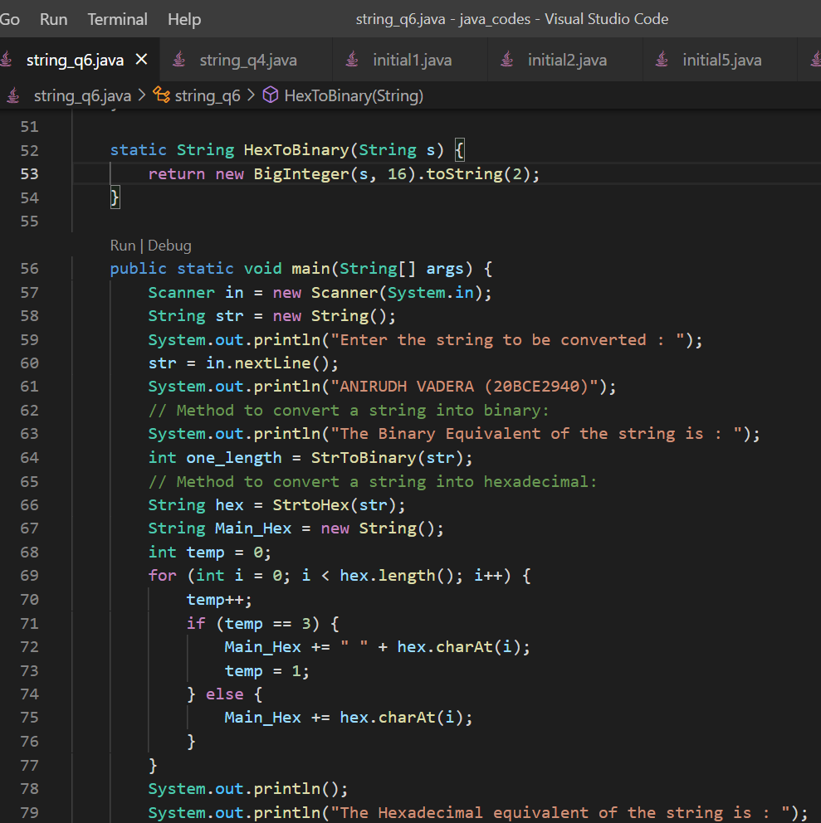

**OUTPUT:**

